KURO

Information for invitation to tender

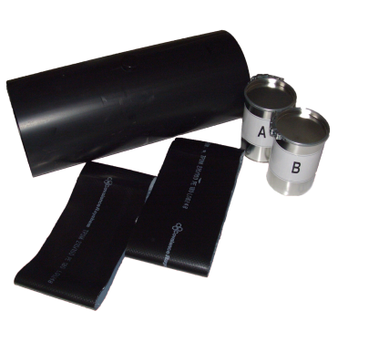
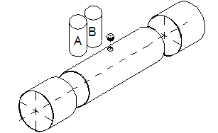
Product:

PVC Underground Sleeve
- with Accessories (2 shrink hoses,
1 plug, component A+B)
- without PVC-forwarding sleeve,
available separately

Text for Invitation to tender:

 | Pos: ....................... | PVC Underground sleeve - NW 55  for PVC Underground tube 60 x 2.5 mm
 |  | with 2 shrink hoses, 1 plug, component A+B (without forwarding sleeve)
 |  | System KURO or equal (www.kuro-kunststoffe.com),
 |  | deliver and assemble
 |  | Quantity: ............ piece Price/Unit: .......... Price total: ..........

 | Pos: ....................... | PVC Underground sleeve - NW 63  for PVC Underground tube 63 x 1.9 mm
with 2 shrink hoses, 1 plug, component A+B (without forwarding
sleeve)
 |  | System KURO or equal (www.kuro-kunststoffe.com),
 |  | deliver and assemble
 |  | Quantity: ............ piece Price/Unit: .......... Price total: ..........
 | Pos: ....................... | PVC Underground sleeve - NW 65  for PVC Underground tube 70 x 2.5 mm
with 2 shrink hoses, 1 plug, component A+B (without forwarding
sleeve)
 |  | System KURO or equal (www.kuro-kunststoffe.com),
 |  | deliver and assemble
 |  | Quantity: ............ piece Price/Unit: .......... Price total: ..........

 | Pos: ....................... | PVC Underground sleeve - NW 75  for PVC Underground tube 80 x 2.5 mm
with 2 shrink hoses, 1 plug, component A+B (without forwarding
sleeve)
 |  | System KURO or equal (www.kuro-kunststoffe.com),
 |  | deliver and assemble
 |  | Quantity: ............ piece Price/Unit: .......... Price total: ..........

 | Pos: ....................... | PVC Underground sleeve - NW 90  for PVC Underground Tube 90 x 2.0 mm
with 2 shrink hoses, 1 plug, component A+B (without forwarding
sleeve)
 |  | System KURO or equal (www.kuro-kunststoffe.com),
 |  | deliver and assemble
 |  | Quantity: ............ piece Price/Unit: .......... Price total: ..........

 | Pos: ....................... | PVC Underground sleeve - NW 100  for PVC Underground tube 108 x 4.0 mm
with 2 shrink hoses, 1 plug, component A+B (without forwarding
sleeve)
 |  | System KURO or equal (www.kuro-kunststoffe.com),
 |  | deliver and assemble
 |  | Quantity: ............ piece Price/Unit: .......... Price total: ..........

 | Pos: ....................... | PVC Underground sleeve - NW 110  for PVC Underground tube 110 x 2.3 mm
with 2 shrink hoses, 1 plug, component A+B (without forwarding
sleeve)
 |  | System KURO or equal (www.kuro-kunststoffe.com),
 |  | deliver and assemble
 |  | Quantity: ............ piece Price/Unit: .......... Price total: ..........

 | Pos: ....................... | PVC Underground sleeve - NW 125  for PVC Underground tube 125 x 2.6 mm
with 2 shrink hoses, 1 plug, component A+B (without forwarding
sleeve)
 |  | System KURO or equal (www.kuro-kunststoffe.com),
 |  | deliver and assemble
 |  | Quantity: ............ piece Price/Unit: .......... Price total: ..........

 | Pos: ....................... | PVC Underground sleeve - NW 124  for PVC Underground tube 132 x 4.0 mm
with 2 shrink hoses, 1 plug, component A+B (without forwarding
sleeve)
 |  | System KURO or equal (www.kuro-kunststoffe.com),
 |  | deliver and assemble
 |  | Quantity: ............ piece Price/Unit: .......... Price total: ..........

 | Pos: ....................... | PVC Underground sleeve - NW 160  for PVC Underground tube 160 x 3.2 mm
with 2 shrink hoses, 1 plug, component A+B (without forwarding
sleeve)
 |  | System KURO or equal (www.kuro-kunststoffe.com),
 |  | deliver and assemble
 |  | Quantity: ............ piece Price/Unit: .......... Price total: ..........

 | Pos: ....................... | PVC Underground sleeve - NW 200  for PVC Underground tube 200 x 4.0 mm
with 2 shrink hoses, 1 plug, component A+B (without forwarding
sleeve)
 |  | System KURO or equal (www.kuro-kunststoffe.com),
 |  | deliver and assemble
 |  | Quantity: ............ piece Price/Unit: .......... Price total: ..........

 | Pos: ....................... | PVC Underground Tube - NW 315  for PVC Underground tube 315 x 6,2 mm
with 2 shrink hoses, 1 plug, component A+B (without forwarding
sleeve)
 |  | System KURO or equal (www.kuro-kunststoffe.com),
 |  | deliver and assemble
 |  | Quantity: ............ piece Price/Unit: .......... Price total: ..........

